STIEBEL ELTRON exceeds one billion in turnover
At the end of November, the STIEBEL ELTRON Group reached a milestone in its company history: annual turnover exceeded the magic mark of one billion euros after just eleven months. "This is a great success that everyone in the company can be proud of," says Managing Director Dr. Kai Schiefelbein, and continues: "The increase is of course largely due to the enormous growth in heat pump sales, but all the other product groups also played their part in the success."

In 2017, turnover was still around half of what it is now - more than 500 million euros were on the annual balance sheet at the time. In each of the following years, new records were reported: from 550 million in 2018, turnover climbed to 594 million euros in 2019 and 700 million euros in 2020. Last year, it was already 830 million euros, and now the billion has been reached. "Of course, we are currently benefiting greatly from the global political situation with our portfolio," explains Schiefelbein, "and yet it is just as much a truth that far-sighted decisions in the past, especially the consistent adherence to the environmentally friendly heating system heat pump and thus the focus on renewable energies, as well as investments in technology and production were and are the basis for this success."
About STIEBEL ELTRON
STIEBEL ELTRON is an internationally operating Group and is among the global market and technology leaders in the fields of building services and renewable energies. Since 1924, technical performance, quality, innovation, reliability and customer-oriented service have been defining factors in our success. With four national and four international production facilities, 26 sales organisations around the world, plus partners and agencies in 120 countries, STIEBEL ELTRON has a global presence. The annual turnover amounts to more than 800 million Euros. More than 50 per cent of the turnover is generated abroad.
In 1924 in Berlin the company founder Dr Theodor Stiebel started realising his vision of developing and manufacturing products with low energy consumption, greater safety and more comfort. This objective still applies to the company today.

Picture 1:
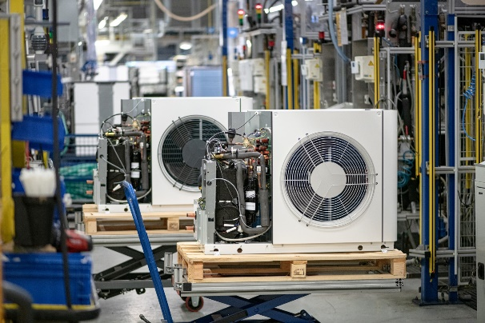 |  | Milestone in Stiebel Eltron's company history: The heat pump manufacturer exceeds the one billion mark in turnover.

